Question 1:

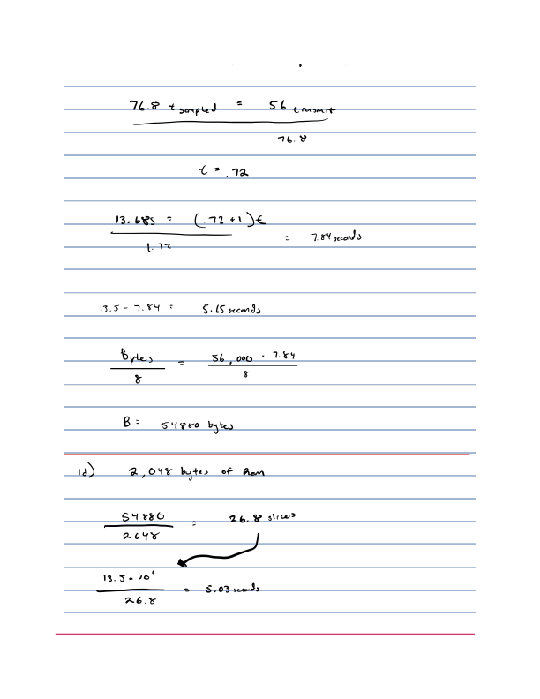

Question 2:

Install tool chains for embedded software development. You may need to install an OS VM first, and then install the tools in the OS VM.

2a) If needed, install cross-compilers: avr-gcc (Linux or Windows) and xc16-gcc (Linux, Windows, Mac)

Report the following:

a.1) The version of the compiler



AVR Chip: 5.4.0

XC16: 1.35

a.2) The source where you download the tools

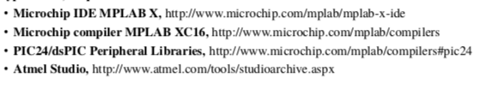

Source is from the syllabus, the links above take you to the download page, except for the last one for the Atmel Studio in which instead is located:



a.3) The folder where the compiler is installed



On my windows virtual machine the C compiler is located:

﻿C:\Program Files (x86)\Atmel\Studio\7.0\toolchain\avr8\avr8-gnu-toolchain\bin\avr-gcc.exe

C++ Compiler

﻿C:\Program Files (x86)\Atmel\Studio\7.0\toolchain\avr8\avr8-gnu-toolchain\bin\avr-g++.exe

a.4) The names of the avr-xxx executables and the xc16-xxx executables, for example, avr-gcc, avr-objdump and etc.

The image above includes the AVR paths, while the image below will show the xc16-xxx executable files



2b) Install IDE: Atmel Studio (Windows) and MPLab X (Linux, Windows, Mac). Create a new C project in the IDEs, select the target chips we use in class (ATMega128 and PIC24ep512ug810), and select simulator as the target platform.

Report the following:

b.1) A screen short of a C project in AVR Stuido with the project management window open,



b.2) The default gcc options of the project in AVR Studio,

﻿-x c -DDEBUG -DBOARD=USER_BOARD -I"C:\Program Files (x86)\Atmel\Studio\7.0\Packs\atmel\ATmega_DFP\1.2.209\include" -I"../src/ASF/common/boards/user_board" -I"../src/ASF/common/boards" -I"../src/ASF/mega/utils/preprocessor" -I"../src/ASF/mega/utils" -I"../src/ASF/common/utils" -I"../src" -I"../src/config" -O1 -fdata-sections -ffunction-sections -fdata-sections -fpack-struct -fshort-enums -mrelax -g3 -Wall -mmcu=atmega128 -B "C:\Program Files (x86)\Atmel\Studio\7.0\Packs\atmel\ATmega_DFP\1.2.209\gcc\dev\atmega128" -c -std=gnu99 -fno-strict-aliasing -Wstrict-prototypes -Wmissing-prototypes -Werror-implicit-function-declaration -Wpointer-arith -mrelax -MD -MP -MF "$(@:%.o=%.d)" -MT"$(@:%.o=%.d)" -MT"$(@:%.o=%.o)"

b.3) A screen short of a C project in MPLab X with the project management window open,



b.4) The default gcc options of the project in MPLab X.

﻿"C:\Program Files (x86)\Microchip\xc16\v1.35\bin\xc16-gcc.exe" helloworldtest.c -o build/default/production/ helloworldtest.o -c -mcpu=24EP512GU810 -MMD -MF "build/default/production/ helloworldtest.o.d" -mno-eds-warn -g -omf=elf -DXPRJ_default=default -legacy-libc -O0 -msmart-io=1 -Wall -msfr-warn=off

"C:\Program Files (x86)\Microchip\xc16\v1.35\bin\xc16-gcc.exe" -o dist/default/production/hw1a.X.production.elf build/default/production/ helloworldtest.o -mcpu=24EP512GU810 -omf=elf -DXPRJ_default=default -legacy-libc -Wl,--local-stack,,--defsym=__MPLAB_BUILD=1,,--script=p24EP512GU810.gld,--stack=16,--check-sections,--data-init,--pack-data,--handles,--isr,--no-gc-sections,--fill-upper=0,--stackguard=16,--no-force-link,--smart-io,-Map="dist/default/production/hw1a.X.production.map",--report-mem,--memorysummary,dist/default/production/memoryfile.xml

Question 3:

Compile the C file hw1.q3.c, and read and understand the assembly code of the program.

First, run "avr-gcc -g -mmcu=atmega128 -o hw1.q3.avr hw1.q3.c" to compile the code.

Then, run "avr-objdump -j .data -j .text -DS hw1.q3.avr > hw1.q3.avr.asm" to dump the assembly code.

Both "hw1.q3.avr" and "hw1.q3.avr.asm" are provided to you already in the package. But, you still need to complete the first two steps as a practice.

Read "hw1.q3.avr.asm" in the package, and report the following:

1. Convert all bytes in the .data section to ASCII chars. Discuss what is the data in the .data section.

When looking into the .data section of the code in the we find that the first two values within the ori line represent the characters h and e based off of the hexadecimal representation of the numbers. From there the next line refers to the two l’s then the line after that refers to the o. The next line following containing (77 6f) refer to wo; while the next line accounts for rl, and the next finally refer to d!. Based off of the next line 0a 00 it represent a space, then continues to repeat the same information stated above. The overall text output from the section of code is helloworld! helloworld!

1. How is the char array buf[] represented in AVR?

Due to the memory locations of 98-b0 being setup to store the data from the chars, and copy the data into the array this is the correct section.

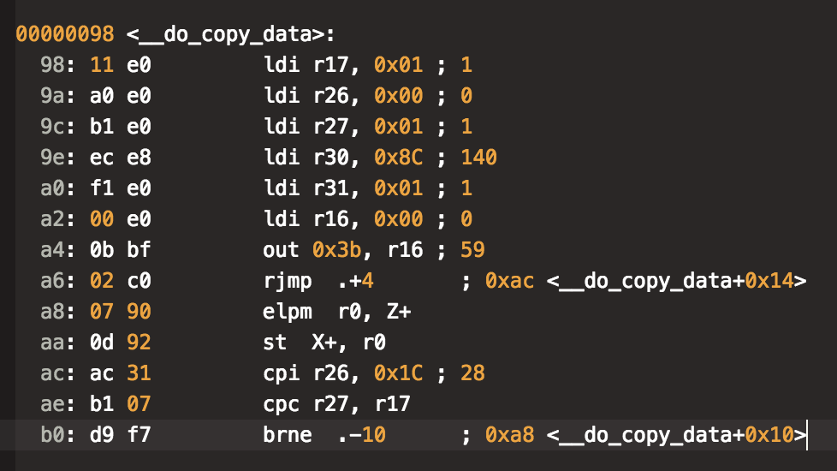

1. Copy and paste the assembly code of the strncpy() function, and comment each line of the assembly code.

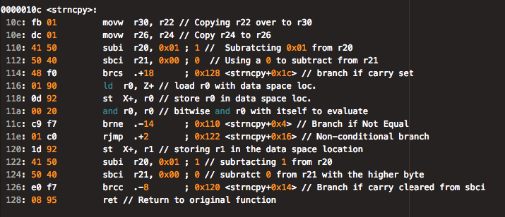

1. Discuss how the arguments are passed to , and how the return value is passed back to the calling function.

When looking at the avr code, we find that due to registers r8- r27 being classified as call-used registers, these would act as saving the register locations between calls. We find that in the section of code below that the function is being loaded up by using the ldi command and placing the values into the respective registers, by first allocating 20 bytes of storage to the r20 register, then placing the rest of the arguments in the other registers to handle the extra memory that will be needed in order to compute the data. With that data the code below is setting the register r28 which is a call-saved register to be set to the value of r24 which in this case will act as the return value. What we find is that once we call the function using the “call” command we are able to get the values from the strncpy function and it will return those values into r24. Hence why within the copy function it just calls rtn, to place the info into the array.

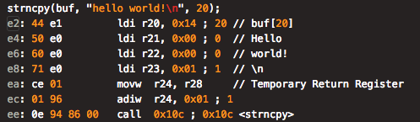

e) Copy and paste the assembly code of the puts() function, and comment each line of the assembly code.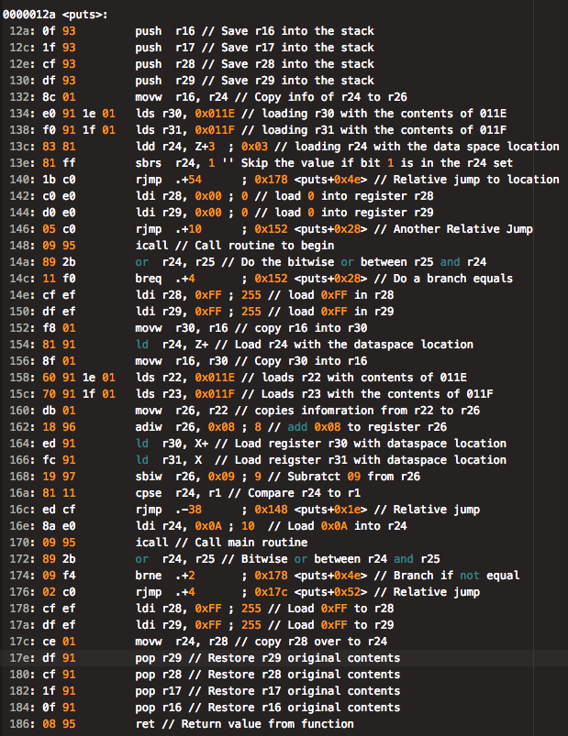

1. Discuss how the arguments are passed to puts(), and how the return value is passed back to the calling function.

When looking at the main function we find that after run the strcopy command we will place the helloworld! \ n into the respective registers, which then will get . The arguments are being passed through 24 and 25 and the values from the puts function is being placed into r28 register which is being returned to the main function due to the r28 register being a call-saved which would preserve the return value after the call.